Playbook: ASP.NET Core → Docker → AKS → Azure DevOps CI/CD

Prerequisites
- dotnet SDK (used: 9.0.304)
- Docker Desktop — must be running before any docker build
- Azure CLI — logged in via az login
- kubectl (ships with Docker Desktop, or install separately)
- An Azure subscription with permission to create resource groups
- An Azure DevOps organization + project (see step 8)
Verify tools:
dotnet --version
docker version --format '{{.Server.Version}}'
az account show
kubectl version –client
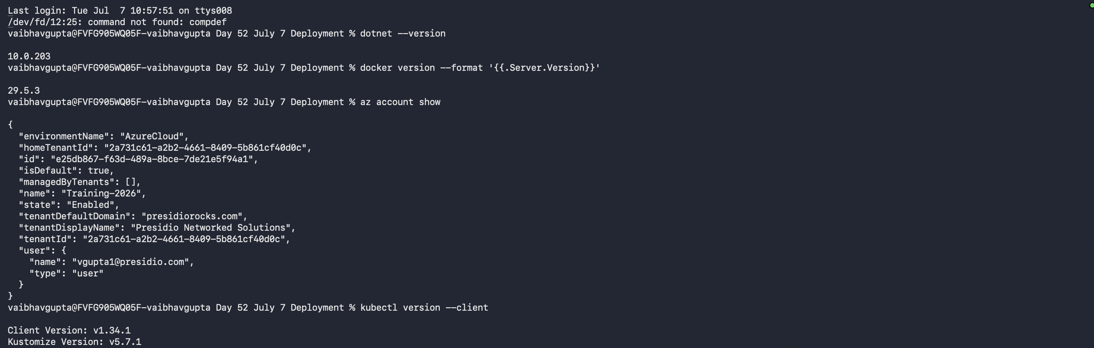

1. Scaffold the app
dotnet new webapi -n HelloAzureApi -o . --use-controllers false
dotnet build
This creates Program.cs, HelloAzureApi.csproj, and the default /weatherforecast minimal API.
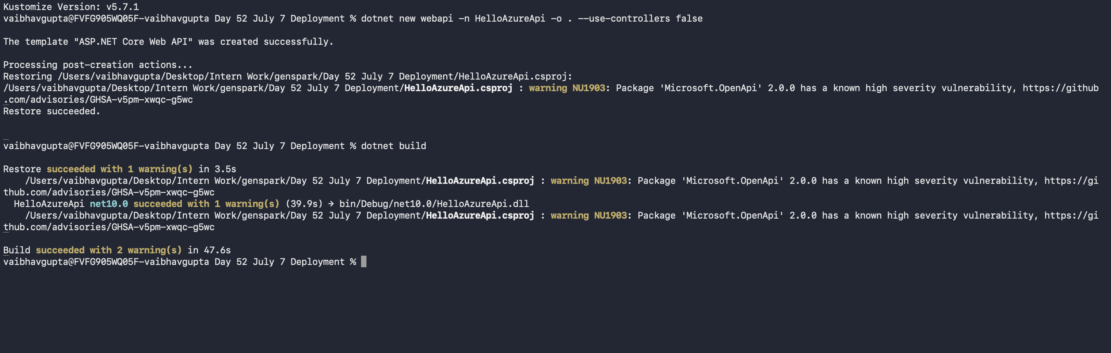

2. Add a Dockerfile
Dockerfile:
FROM mcr.microsoft.com/dotnet/sdk:9.0 AS build
WORKDIR /src
COPY HelloAzureApi.csproj .
RUN dotnet restore
COPY . .
RUN dotnet publish -c Release -o /app --no-restore

FROM mcr.microsoft.com/dotnet/aspnet:9.0 AS runtime
WORKDIR /app
COPY --from=build /app .
EXPOSE 8080
ENV ASPNETCORE_URLS=http://+:8080
ENTRYPOINT ["dotnet", "HelloAzureApi.dll"]
.dockerignore:
bin/
obj/
.claude/
*.md

3. Build and test the container locally
docker build -t helloazureapi:local .
docker run -d --name helloazure-test -p 18080:8080 helloazureapi:local
curl http://localhost:18080/weatherforecast
docker rm -f helloazure-test
Use a host port other than 8080 if something else already owns it locally.
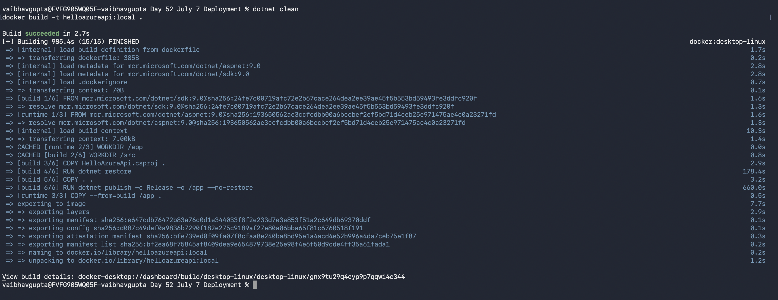
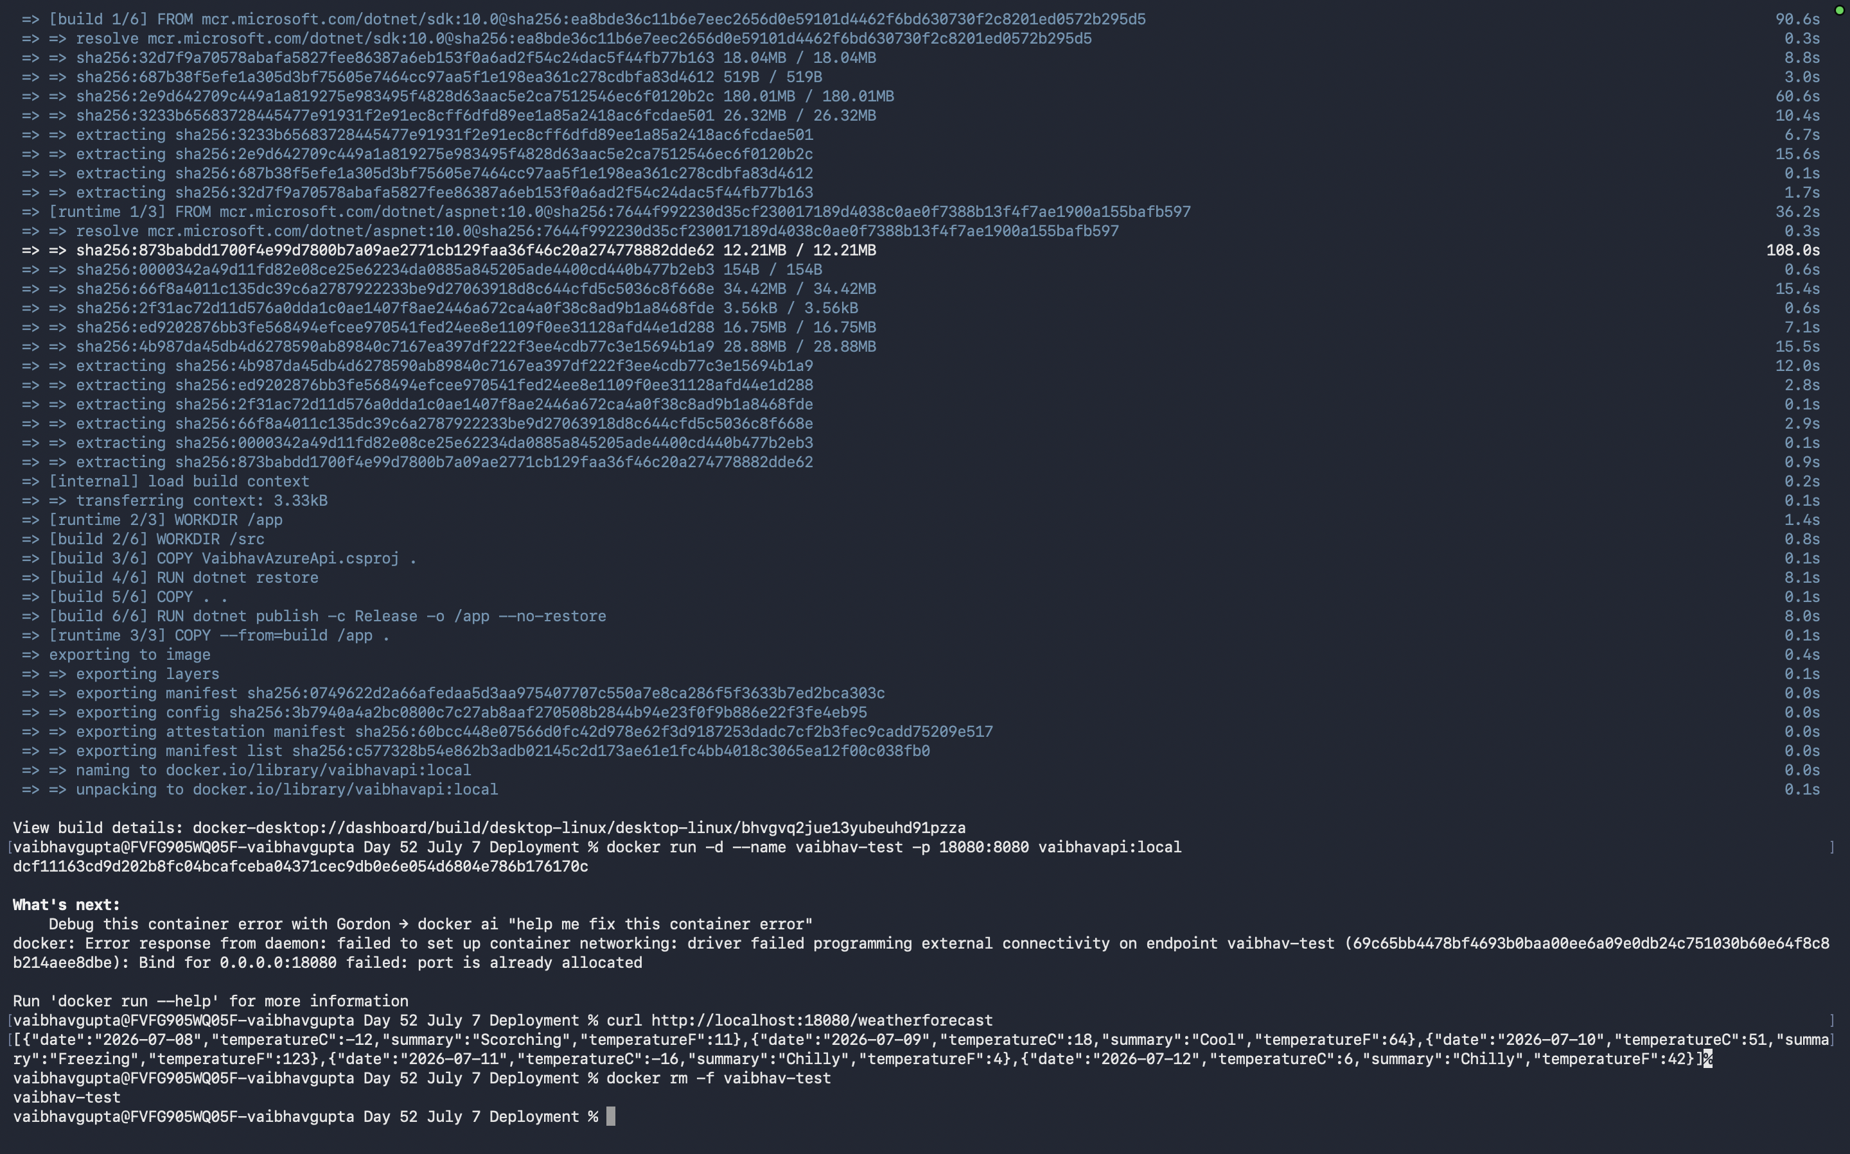

4. Provision Azure resources
Pick a region and a globally unique ACR name.
az group create --name helloazure-rg --location eastus

# ACR name must be globally unique, alphanumeric only
az acr create --resource-group helloazure-rg --name helloazureacr26957 --sku Basic

# Minimal, cost-conscious cluster: 1 node, burstable VM, ACR pre-attached
az aks create \
--resource-group helloazure-rg \
--name helloazure-aks \
--node-count 1 \
--node-vm-size Standard_B2s \
--attach-acr helloazureacr26957 \
--generate-ssh-keys \
--tier free
az aks create takes 5–10 minutes. Cost note: a running AKS cluster + LoadBalancer bills continuously (roughly $70–150+/month depending on size) — delete resources when done experimenting (az group delete --name helloazure-rg).

5. Push the image to ACR
az acr login --name helloazureacr26957
docker tag helloazureapi:local helloazureacr26957.azurecr.io/helloazureapi:v1
docker push helloazureacr26957.azurecr.io/helloazureapi:v1

6. Kubernetes manifests
k8s/deployment.yaml:
apiVersion: apps/v1
kind: Deployment
metadata:
name: helloazureapi
labels:
app: helloazureapi
spec:
replicas: 1
selector:
matchLabels:
app: helloazureapi
template:
metadata:
labels:
app: helloazureapi
spec:
containers:
- name: helloazureapi
image: helloazureacr26957.azurecr.io/helloazureapi:v1
ports:
- containerPort: 8080
resources:
requests:
cpu: 100m
memory: 128Mi
limits:
cpu: 250m
memory: 256Mi
k8s/service.yaml:
apiVersion: v1
kind: Service
metadata:
name: helloazureapi
spec:
type: LoadBalancer
selector:
app: helloazureapi
ports:
- protocol: TCP
port: 80
targetPort: 8080

7. Deploy and verify
az aks get-credentials --resource-group helloazure-rg --name helloazure-aks --overwrite-existing
kubectl apply -f k8s/deployment.yaml -f k8s/service.yaml
kubectl wait --for=condition=Ready pod -l app=helloazureapi --timeout=90s
kubectl get svc helloazureapi # note the EXTERNAL-IP
curl http://<EXTERNAL-IP>/weatherforecast
At this point the app is live, deployed manually. Everything after this sets up CI/CD so future pushes deploy automatically.

8. Create an Azure DevOps org and project
- Go to https://dev.azure.com, sign in with the Microsoft account tied to your Azure subscription.
- Create an organization (or use the auto-created one) — pick a unique name and a region.
- Create a project (e.g. SampleAPI).

9. Initialize git and push the code
Azure DevOps orgs backed by a Microsoft account (not Entra ID/work account) require a Personal Access Token (PAT) for git operations — an az account get-access-token bearer token will not authenticate.
- Create a PAT: User settings → Personal access tokens → New Token, scopes: Code (Read & Write), Build (Read & execute), Service Connections (Read, query & manage).
- Initialize and push:
git init
git add -A
git commit -m "Initial commit"
git remote add origin https://dev.azure.com/<your-org>/<your-project>/_git/<your-repo>
git push -u origin master
# username: your Azure DevOps email, password: the PAT
.gitignore used:
bin/
obj/
.vs/
*.user
.claude/

10. Create the Azure service connection
In the Azure DevOps project:
- Project Settings → Service connections → New service connection
- Choose Azure Resource Manager → Service principal (automatic)
- Select your subscription, scope to the resource group (helloazure-rg)
- Name it AzureServiceConnection (or update the pipeline variable to match)
- Grant access permission to all pipelines
This is the only service connection needed — the pipeline uses az acr build and az aks get-credentials, so no separate Docker registry connection is required.

11. Pipeline YAML
Template the image tag in k8s/deployment.yaml so the pipeline controls versioning:
image: __ACR_LOGIN_SERVER__/helloazureapi:__IMAGE_TAG__
azure-pipelines.yml:
trigger:
branches:
include:
- master

pool:
vmImage: ubuntu-latest

variables:
azureServiceConnection: 'AzureServiceConnection'
resourceGroup: 'helloazure-rg'
acrName: 'helloazureacr26957'
aksName: 'helloazure-aks'
imageName: 'helloazureapi'
imageTag: '$(Build.BuildId)'

stages:
- stage: Build
displayName: Build and push image to ACR
jobs:
- job: BuildAndPush
steps:
- task: AzureCLI@2
displayName: az acr build
inputs:
azureSubscription: $(azureServiceConnection)
scriptType: bash
scriptLocation: inlineScript
inlineScript: |
az acr build \
--registry $(acrName) \
--image $(imageName):$(imageTag) \
.

- stage: Deploy
displayName: Deploy to AKS
dependsOn: Build
jobs:
- job: DeployToAks
steps:
- task: AzureCLI@2
displayName: kubectl apply
inputs:
azureSubscription: $(azureServiceConnection)
scriptType: bash
scriptLocation: inlineScript
inlineScript: |
az aks get-credentials \
--resource-group $(resourceGroup) \
--name $(aksName) \
--overwrite-existing

sed -i \
-e "s#__ACR_LOGIN_SERVER__#$(acrName).azurecr.io#g" \
-e "s#__IMAGE_TAG__#$(imageTag)#g" \
k8s/deployment.yaml

kubectl apply -f k8s/deployment.yaml -f k8s/service.yaml
kubectl rollout status deployment/helloazureapi --timeout=120s
Commit and push this file.

12. Create and run the pipeline
- Pipelines → New pipeline → Azure Repos Git → select your repo
- Existing Azure Pipelines YAML file → branch master, path /azure-pipelines.yml
- Save and run
From then on, every push to master builds a new image tagged with the DevOps build number and rolls it out to AKS automatically.

Cleanup (avoid ongoing charges)
az group delete --name helloazure-rg --yes --no-wait

